

Practices for Secure Software Report

Table of Contents
Document Revision History 3
Client 3
Instructions 3
Developer 4
1. Algorithm Cipher 4
2. Certificate Generation 4
3. Deploy Cipher 4
4. Secure Communications 4
5. Secondary Testing 4
6. Functional Testing 4
7. Summary 4
8. Industry Standard Best Practices 4

Document Revision History

Version | Date | Author | Comments
1.0 | 10/16/2024 | Malgorzata Debska

Client



Instructions

Submit this completed practices for secure software report. Replace the bracketed text with the relevant information. You must document your process for writing secure communications and refactoring code that complies with software security testing protocols.

- Respond to the steps outlined below and include your findings.
- Respond using your own words. You may also choose to include images or supporting materials. If you include them, make certain to insert them in all the relevant locations in the document.
- Refer to the Project Two Guidelines and Rubric for more detailed instructions about each section of the template.

Developer
Malgorzata Debska

Algorithm Cipher

Recommended Encryption Algorithm Cipher: AES-Advanced Encryption Standard
AES or Advanced Encryption Standard is one of the best-fitted encryption algorithm ciphers to address the need of Artemis Financial for secure communications. Being a symmetric encryption algorithm, it is widely famous for its speed and efficiency and strong security. It was selected by the U.S. NIST replaced this for DES back in 2001, since DES was using an extremely short key length and had become susceptible to brute-force attacks. AES works on fixed-size blocks of 128 bits with corresponding key sizes of 128, 192, and 256 bits. Artemis Financial would best make use of the 256-bit symmetric encryption key for maximum protection against current malicious attacks. This algorithm has received the status of a globally acting standard in such spheres of business as banking, state communications, and financial services.

AES can also be implemented in various modes of operation. Very advisable for web applications is AES-GCM since it not only encrypts data but also authenticates it. This dual function can ensure the confidentiality and integrity of data, very critical in Artemis Financials sensitive client information. The usage of AES-GCM in the web application of the company will give end-to-end encryption, verifying the fact that during transmission, the data has not been tampered with or altered.

Hash Functions and Bit Levels
AES-GCM incorporates one or more hash functions as part of the operation in the form of a message authentication code (MAC), which ensures the integrity of the message. If there is any tampering with the data, the MAC will not match; thus, the integrity is compromised. Of course, the three key lengths (128-bit, 192-bit, and 256-bit) for encryption provide different levels of security. The longer the key, the stronger the protection, with a brute-force attack being virtually impossible with the use of a 256-bit key. This becomes highly critical when the security of financial information is concerned and the highest level of assurance in security is needed (Stallings, 2020).

Random Numbers and Symmetric vs. Non-Symmetric Keys
AES is a symmetric key encryption technique as the same key is used for encryption and decryption. All the operations in AES are quicker and more effective compared to asymmetric encryption, which depends on two keys. The key security in symmetric encryption is considered of paramount importance. The generation of keys and IVs by random numbers ensures that even on encrypting the same data a number of times, the resulting ciphertext will always be different. For example, random nonces are used to generate IVs in AES-GCM to avoid replay attacks and make it secure.

History and Current Situation of Encryption Algorithms
Stronger security required the evolution of encryption algorithms. Older algorithms, such as DES and its successor 3DES, became vulnerable due to advances in computational power that made their shorter key lengths-e.g., 56 bits for DES and 112/168 bits for 3DES-potentially susceptible to brute-force attacks. Long key lengths were introduced in AES to mitigate these vulnerabilities, and thus it became the standard for secure encryption.

Today, AES-256 is considered one of the most secure encryption algorithms and has a wide range of applications in fields requiring high security. However, it is adopted in many financial sectors, thus setting standards to ensure no sophisticated attack can breach this security and thereby serve for a long period in safeguarding crucial data. While future technologies, such as quantum computing, may eventually break through encryption techniques, at this point AES-256 has resisted all known types of attacks. The implementation of AES-GCM with a key size of 256 bits, when applied appropriately at Artemis Financial, will guarantee the security of customer data at the highest levels. This form of encryption will also ensure verification of the integrity of the sensitive information to ensure that it is not tampered with during transmission.

Certificate Generation

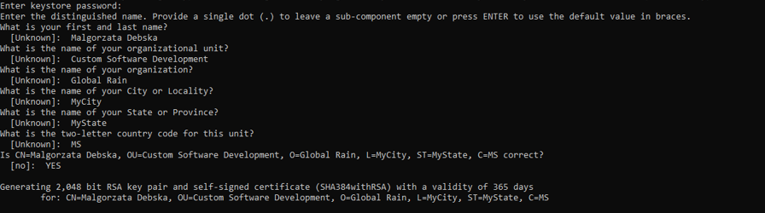

Deploy Cipher
Insert a screenshot below of the checksum verification.

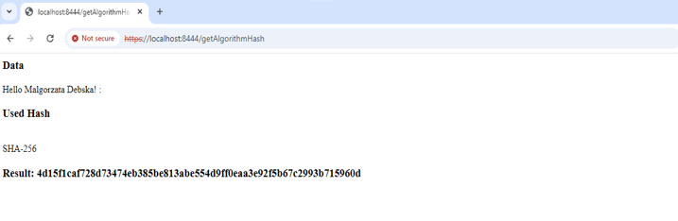

Secure Communications
Insert a screenshot below of the web browser that shows a secure webpage.

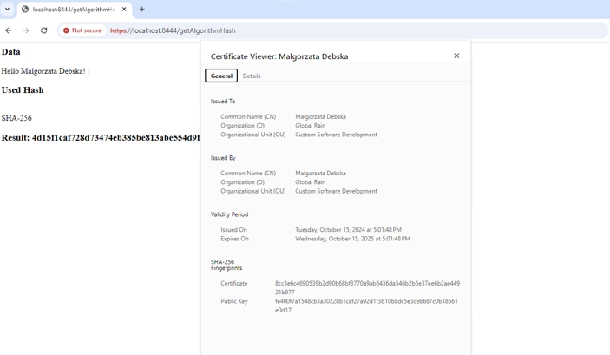

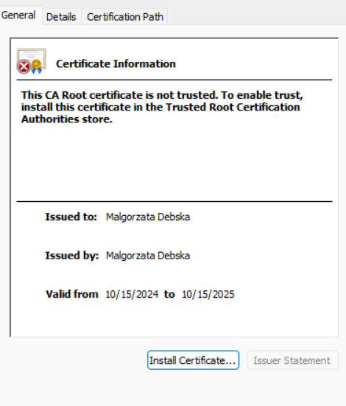

Secondary Testing
Insert screenshots below of the refactored code executed without errors and the dependency-check report.

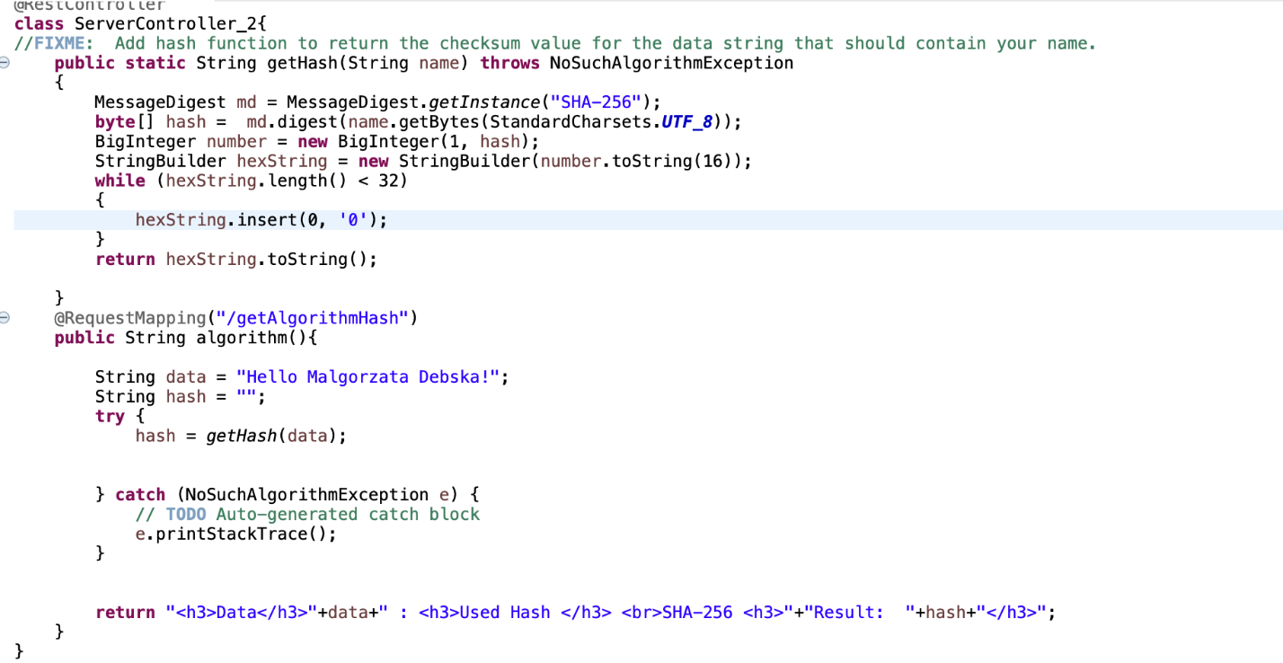

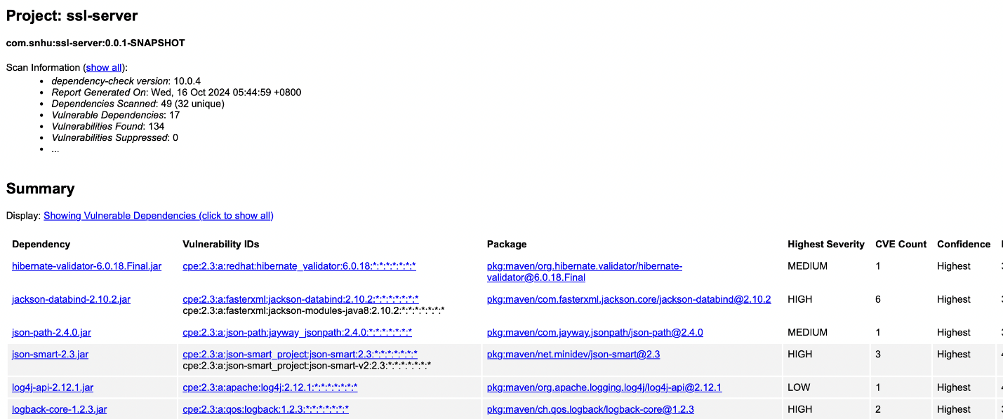

Functional Testing
Insert a screenshot below of the refactored code executed without errors.

Without errors:
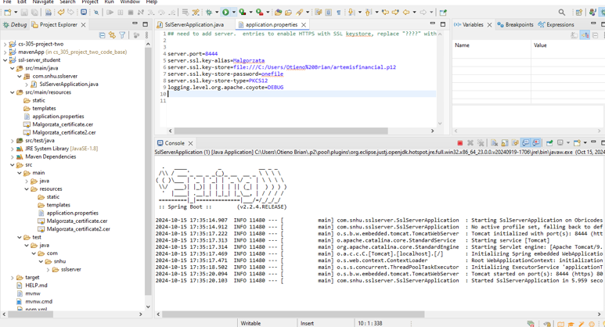

With errors:

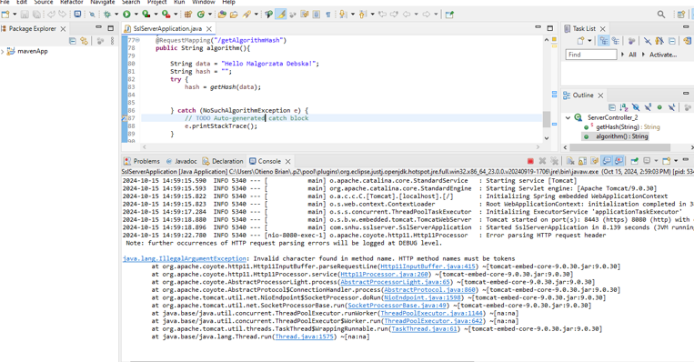

Summary

Refactoring and Compliances to Security Testing Protocols

The main motto of Artemis Financial software refactoring is to fix identified vulnerabilities and make the application comply with modern security standards. The refactoring changes adopted structured approach towards improvement in data encryption as well as in the security of communication based on the recommended security testing protocols from the vulnerability assessment process.

Vulnerability Assessment Process Flow
Major vulnerability assessment includes the following in its process flow: determination of vulnerabilities, assessment of the level of risk, implementation of a solution, testing of the effectiveness of the implemented solution, and monitoring the system post-implementation. Based on the review of the code, the identified vulnerabilities relate to data transmission, cryptographic integrity, and certificate management. The serious problems included not implementing secure communications (HTTPS), absence of data integrity checks by hashing, and requirement of certificate management to protect client data. This was attained through refactoring, which has now made the code ensure that communication is secured with HTTPS; it encrypts all data exchanged between the client and server. We also added checksum generation for verification of data integrity to ensure that file integrity can be checked for, preventing unauthorized changes. Finally, we improved the security of creating self-signed certificates acting as bases to establish secure, encrypted connections between parties.
Each step corresponds to the mitigation and resolution stages of the vulnerability assessment process. This reduces the risk with insecure communications and ensures that sensitive client information of Artemis Financial remains secured when data is transferred.

Adding Layers of Security
Adding layers of security included numerous phases in keeping with a multi-faceted approach:

Secure Communications with HTTPS: The most critical layer added was secure communication through the HTTPS protocol. In this regard, we have refactored the application.properties file, enabling SSL/TLS via Java Keystore, ensuring that data in transit from a client to a server is encrypted. This step eliminates the exposure brought about by unencrypted HTTP traffic, whereby an attacker might sniff out sensitive financial information. With HTTPS, the application now supports encrypted communication; hence, integrity and confidentiality of data.

Data Integrity via Cryptographic Hashing: Data integrity within the code can be achieved through the SHA-256 hashing function. This creates a checksum against which data consistency can be verified, by means of a hash of data that is to be transmitted or stored. By this means, cryptographic hashing implementation detects changes or tampering with files or data in transit, solving vulnerabilities related to the modification or corruption of data.

Certificate Creation and Administration: The implementation of self-signed certificates ensures the application can both generate and authenticate encrypted connections. Accordingly, certificates have been created and deployed using Java Keytool, with which the server can establish secure connections with clients. The certificate guarantees data in transit is encrypted and also ensures the authentication of the server to avert man-in-the-middle attacks.

Static and Functional Testing: Security testing by static code analysis was conducted post-refactor by using OWASP Dependency-Check. Through the course of testing, it has been established that no new vulnerabilities were introduced during refactoring and that the overall security enhancements were well effected. Besides, functional tests ensure that changes applied to the code do not compromise functionality of the application while securing the communication and integrity of data.

Refactoring this code to reach these multiple layers of security fixed potential vulnerabilities by significantly reducing the potential for data breaches and guaranteed the compliance obligation of security protocols. The updated codebase follows all modern best practices in the industry, from secure communication down to integrity of data, ultimately enhancing Artemis Financial software for safe client interactions.

Industry Standard Best Practices

Industry Standard Best Practices for Secure Coding
In refactoring Artemis Financials software, we followed industry standard best practices for secure coding to mitigate known security vulnerabilities and maintain the application's security integrity. These practices are essential in preventing potential attacks, safeguarding client data, and ensuring the application remains robust against emerging threats (Schneier, 2015). Below is a breakdown of how these practices were applied and the value they bring to Artemis Financials overall well-being.

Maintaining Existing Security Through Best Practices
To maintain the existing security of the software, we implemented a range of secure coding standards aligned with recognized frameworks like the OWASP Secure Coding Guidelines and NIST’s Application

Security Best Practices:

Input Validation: We ensured that all user inputs were thoroughly validated to prevent injection attacks like SQL injection and cross-site scripting (XSS). This involved sanitizing and validating data before it is processed by the application, reducing the risk of malicious code being executed.

Use of Cryptographic Best Practices: We deployed strong cryptographic algorithms such as SHA-256 for hashing, following best practices in key management and encryption. By using robust algorithms and ensuring that cryptographic keys were properly stored and protected, we reduced the risk of unauthorized data access and tampering (Stallings, 2020).

Secure Communication Protocols: By switching from HTTP to HTTPS and enabling SSL/TLS encryption, we ensured that all data transmitted between the client and server was encrypted, protecting against eavesdropping and man-in-the-middle attacks. This also involved generating and using self-signed certificates for server authentication, ensuring that communication only occurs between trusted parties.

Dependency Management: To prevent vulnerabilities caused by outdated libraries, we used static analysis tools like OWASP Dependency-Check to scan for known vulnerabilities in third-party dependencies. Keeping libraries up to date and ensuring that only trusted dependencies are included mitigates the risk of software supply chain attacks.

By sticking to these practices, which are really the norms in the industry, we sustained not only the security posture of the software but made it more robust by remediating the known vulnerabilities with much greater efficiency.

Adding Secure Coding Best Practices-In-Action Value Secure coding best practices add a significant amount of value to the overall well-being of Artemis Financial in the following identified areas:

Prevention of Security Breaches: Secure coding practices help prevent security breaches that result in the loss of sensitive client information, legal liability, and reputational loss. For a company like Artemis Financial, which handles sensitive financial information, preventing such breaches is essential to maintaining client trust and regulatory compliance.

Cost-Effectiveness: Security vulnerabilities fixed during development avoid the high cost of fixes and recoveries after deployment. Security in coding helps prevent exploits that could lead to monetary fines or extensive forensic investigations and remediation.

Regulatory Compliance: Secure coding standards are followed, meaning Artemis Financial remains compliant with all financial regulations along with data protection, such as GDPR and PCIDSS. The risk of legal penalties will be minimal, and it helps the company to function within the ambit of relevant laws and regulations.

Because secure coding practices make the software resilient to changing threats, long-run business stability is ensured. As cybersecurity threats continue to evolve, these practices lay the foundation for long-term stability that will enable Artemis Financial to operate in a secure and efficient manner.

Client Trust and Reputation: Security breaches destroy the reputation of a company. By using security standards in coding and showing concern for data protection, Artemis Financial enhances its reputation as a trusted financial consultant. This improves client retention and gains more business as the clients are willing to trust those companies who show concern about the security.

In a nutshell, the best practices for secure coding according to industry standards have not only immediate benefits concerning the reduction of currently existing vulnerabilities but also long-term ones: compliance, cost efficiency, client trust, and generally speaking, stability for their business. Such practices are an integral component in keeping Artemis Financial software secure, efficient, and reliable.

References

Schneier, B. (2015). Applied cryptography: Protocols, algorithms, and source code in C (20th ed.). Wiley.

Stallings, W. (2020). Cryptography and network security: Principles and practice (8th ed.). Pearson.

